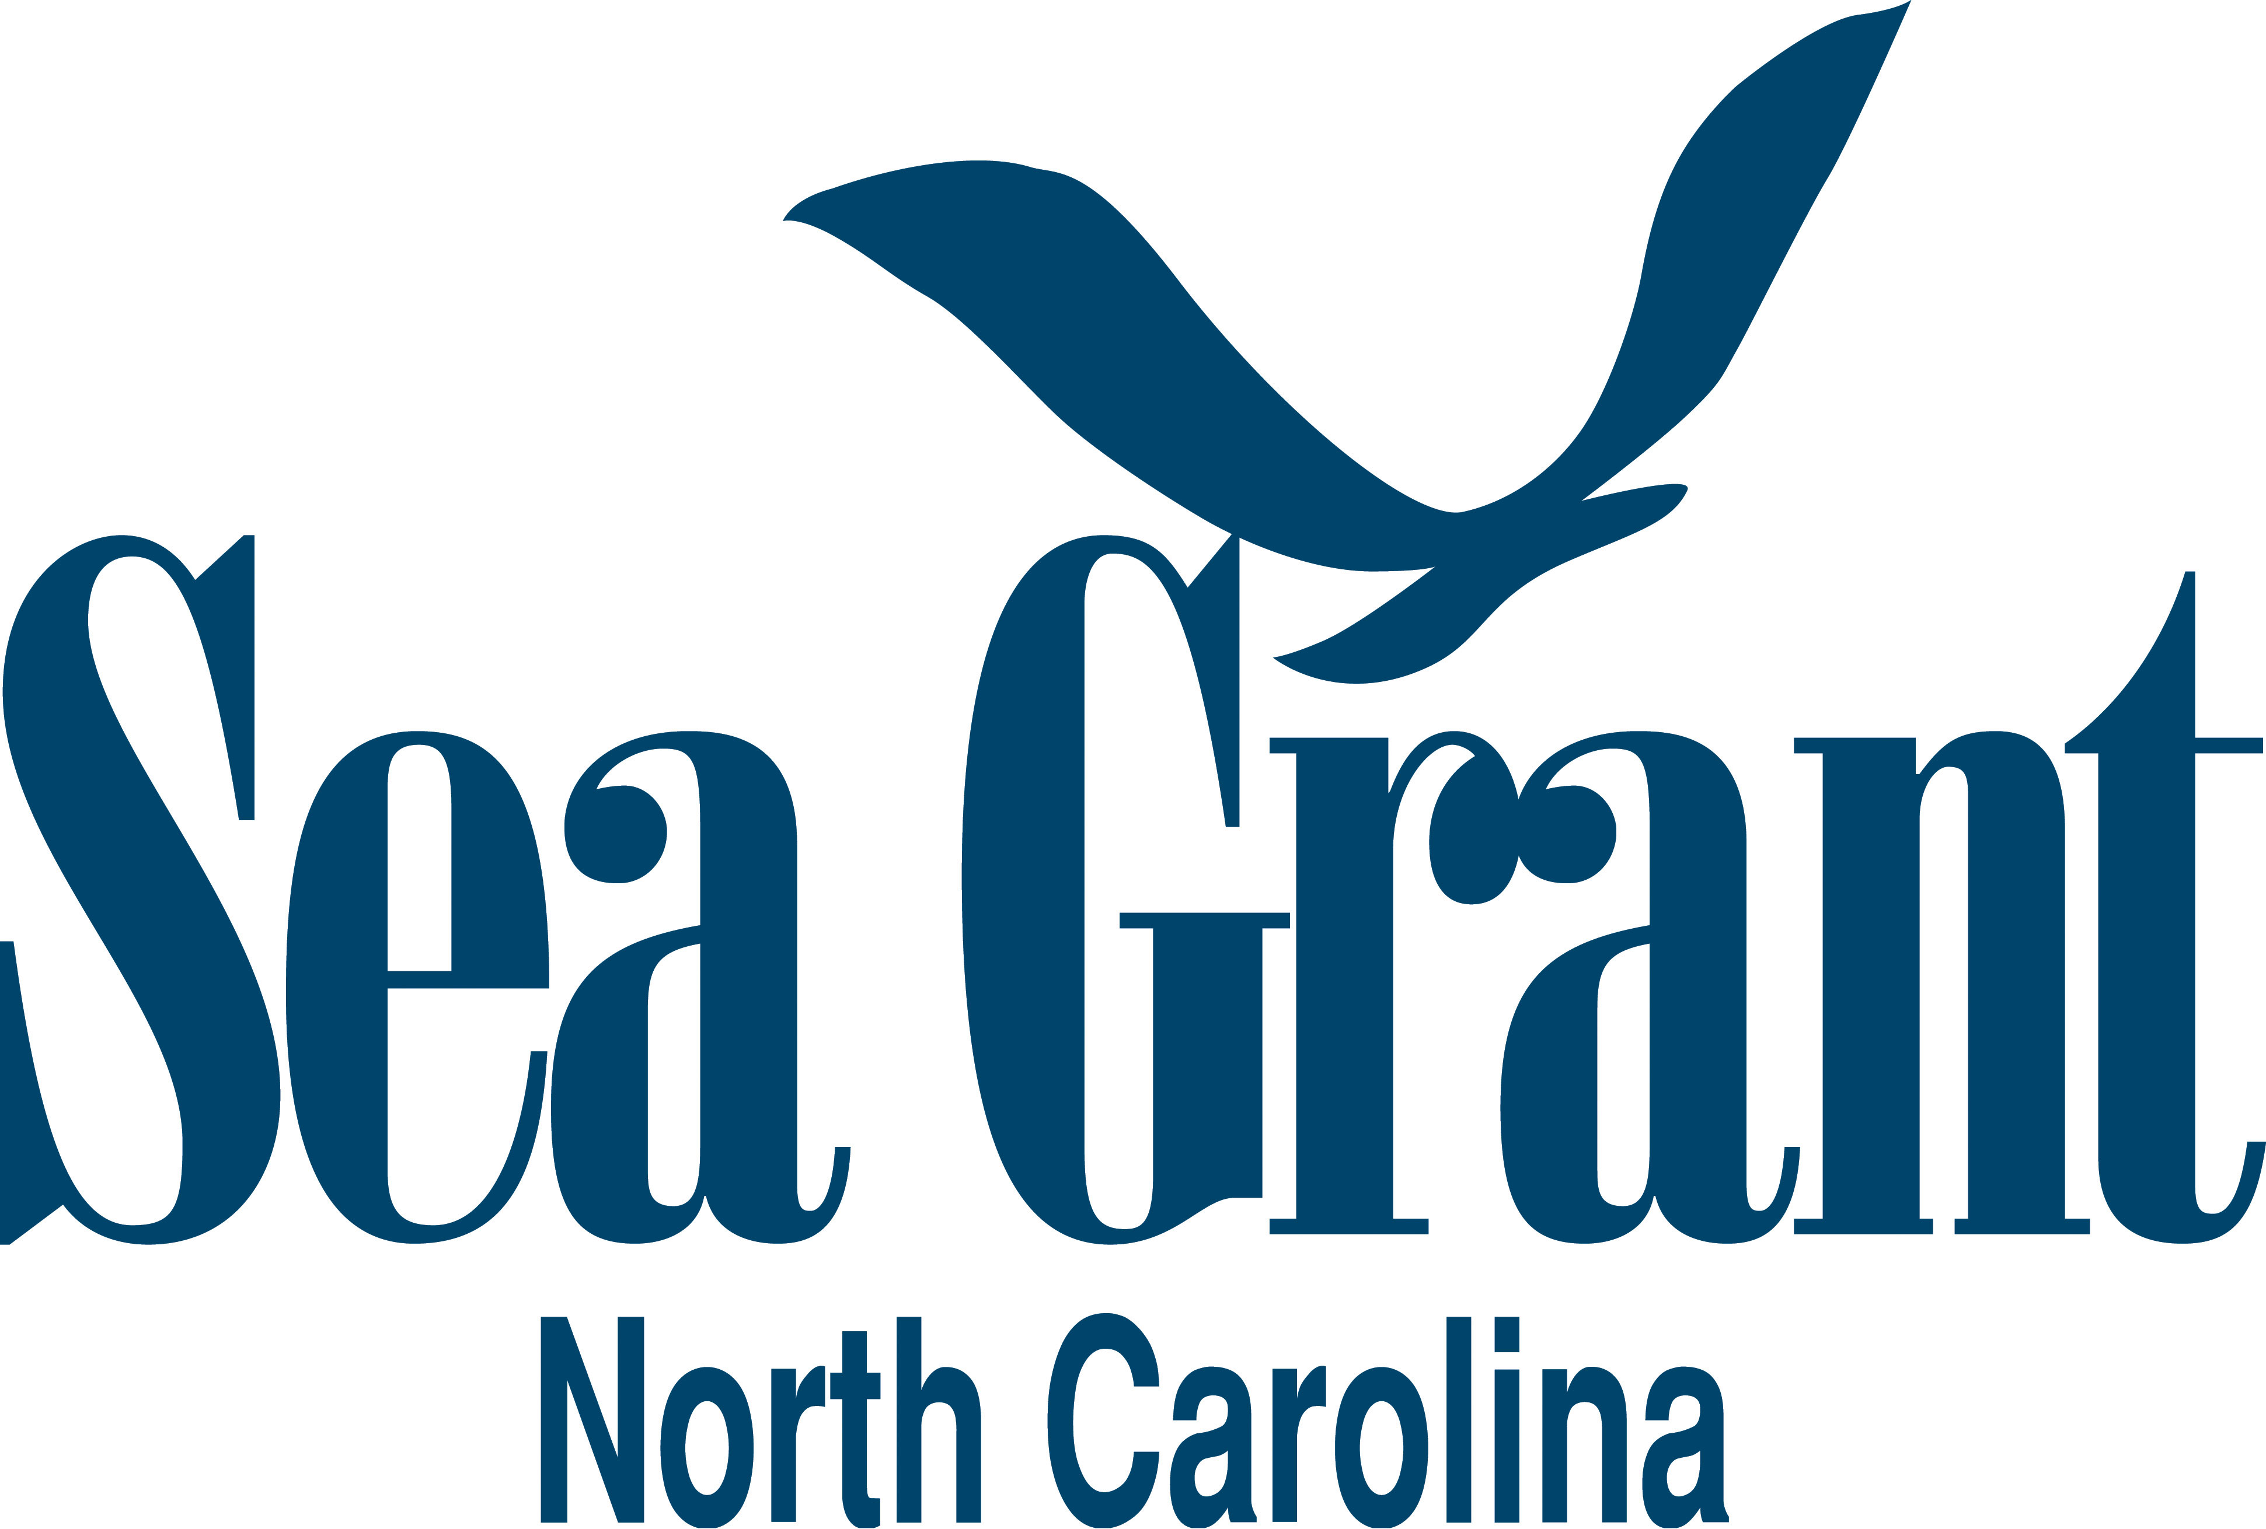
Overview of North Carolina Sea Grant
Oyster Initiatives and Sponsored Research

Current projects NCSG leads or serves on as co-investigator or partner
Expansion and Diversification of the North Carolina Shellfish Aquaculture Industry
NOAA Sea Grant Aquaculture Extension/Technology Transfer Program, 9-1-15 to 8-31-17
PI: C. Weirich (NCSG); co-PIs: D. Cerino (CCC), A. Wilbur and T. Alphin (UNCW), and B. Nash (NCSG)
- Establishment of shellfish aquaculture demonstration centers at Carteret Community College/North Carolina State University Center for Marine Sciences and Technology and the University of North Carolina Wilmington
- Comparison of oyster-culture gear types and performance of native oyster strains
- Evaluation of sunray venus clam culture as a means for crop diversification
- Assessment of shellfish market demand and development of value-added products
Assessment of Occupational Safety and Health Needs and Development of Intervention Opportunities for the North Carolina Aquaculture Industry
Southeast Center for Agricultural Health and Injury Prevention, 11-1-15 to 10-31-16
PI: M. Behm (ECU); co-PIs: L. Grafft (NC Agromedicine Institute) and C. Weirich (NCSG); Partners: J. Hinshaw, S. Gabel, M. Frinkso, and S. Thompson (NCCE)
- Assessment of occupational health and safety needs among aquaculture producers in North Carolina via survey, site visits and interviews
- Develop and prioritize interventions that meet the occupational safety and health needs of the North Carolina aquaculture industry
- Provide baseline data to develop future outreach and research opportunities with respect to aquaculture work safety
Building the Marine Aquaculture Career Pipeline
NOAA Sea Grant Aquaculture Conferences, Workshops, Training, and Information Transfer Program, 9-1-16 to 8-31-18
PI: J. Harrison (NCSG); co-PIs: D. Cerino (CCC), T. Kirby-Hathaway (NCSG), and C. Weirich (NCSG)
- Develop a marine aquaculture curriculum for North Carolina high schools
- Train high school teachers on marine aquaculture concepts and teaching resources
- Expose high school students to marine aquaculture technology and science

South Atlantic Shellfish Initiative Planning Session
NOAA Sea Grant Aquaculture Conferences, Workshops, Training, and Information Transfer Program, 9-1-16 to 2-28-17
PI: J. Davis (SCSGC); co-PIs: T. Bliss (UGA/GSG), C. Weirich (NCSG), L. Sturmer, UF, and T. Getchis (UCONN)
- Conduct planning session involving stakeholders at upcoming 2016 ICSR in Charleston to explore development of a shellfish initiative for the south Atlantic region: Florida, Georgia, North Carolina, South Carolina
- Identification of key players that can help drive a shellfish initiative and maintain buy-in and support
- Determination of policy and research needs for thriving shellfish populations in the south Atlantic to better target Sea Grant research and extension efforts.
Using Oyster Reef Soundscapes to Enhance Oyster Larval Settlement under Commercial
Hatchery Conditions
NC Biotechnology Center, 8-1-16 to 7-31-17
PI: D. Eggleston (NCSU CMAST); co-PI: D. Cerino (CCC); Commercialization Advisors: C. Weirich (NCSG) and R. Carter (MBCOI)
  - Evaluate effect of recorded reef soundscapes on larval settlement on microcultch and oyster shell
  - Laboratory and commercial studies
Marine Aquaculture Law and Policy Research
UNC School of Law, 6-1-16 to 4-30-17
PI: L. Schiavinato (NCSG), Advisor: J. Harrison (NCSG); Research Associate: P. Hilton (UNC School of Law)
- Comparative policy and financial tools for oyster aquaculture
- Marine aquaculture lease permitting regulations
Evaluation of Methods to Control Biofouling of Cultured Oysters (pending)
USDA Southern Regional Aquaculture Center (SRAC), 2-1-17 to 1-31-19
PI: J. Davis (SCSGC); co-PIs: T. Bliss and R. Bringolf (UGA), J. Supan (LSU), W. Walton (UA/MS-AL SG), L. Sturmer (UF), C. Weirich (NCSG), and S. Shumway (UCONN)
- Multi-state project with commercial partner in each state: Alabama, Florida, Georgia, Louisiana, Mississippi, North Carolina and South Carolina
- Evaluation of air drying frequency and anti-fouling coating of floating cages on production and expenses

Current projects sponsored by NCSG
Assessment of Current Production Practices and Economics of the Developing North Carolina Oyster Aquaculture Industry
NCSG Extension internal competition, 1-15-17 to 6-15-17
PI: C. Weirich (NCSG) and J. Harrison (NCSG)
- Production and economic information will be acquired by survey and site visits
- Establishment of template for long-term data acquisition and annual reports
- Development of best management practices
- Farm budget development
Harnessing Positive Interactions at Multiple Scales for Seagrass Restoration
NCSG-APNEP Joint Fellowship Project, 8-1-16 to 3-31-17
Student: S. Zhang (Duke)
- Determine the relative influence of positive interactions at multiple scales on seagrass restoration success
- Explore opportunities to conduct landscape-scale restoration of seagrass beds simultaneously with oyster reef restoration
Integrating Spatial Ecosystem Services Considerations into a GIS-based Decision Support Tool for Oyster Restoration: Application of Remotely-Sensed Chlorophyll a
NCSG-Space Grant Joint Fellowship Project, 9-1-16 to 8-31-16
Student: S. Theuerkauf (NCSU)
- Evaluate the use of satellite-derived chlorophyll a concentrations for Pamlico Sound in conjunction with data on water flow velocities and dissolved oxygen concentrations to identify potential restoration locations that would maximize the oyster ecosystem service of water filtration
Metapopulation Dynamics Guides Oyster Restoration and Habitat Protection
Omnibus Program, 4/1/14 to 12-31-16
PI: D. Eggleston (NCSU CMAST); co-PI: B. Puckett (NCSU CMAST)
- Focus on Pamlico Sound
- Identify and ground-truth locations of intertidal oyster reefs
- Quantify spatiotemporal variation in oyster recruitment, growth, survival and reproductive capacity
- Couple spatially-explicit demographics from this study on intertidal reefs and previous NCSG-funded data from 10 oyster broodstock reserves, as well as fished, subtidal oyster reefs, both natural and cultch-planting sites, to identify larval subsidies from intertidal reefs to cultch sites and natural reefs, no-take reserves and vice versa
- Rank intertidal reef sites according to their larval contribution to the overall oyster metapopulation in Pamlico Sound, as well as specific larval contributions to no-take reserves and fished areas

Effects of Oyster Grow-out Cages on the Condition and Ecosystem Services of Seagrass Communities
Omnibus Program, 2-1-16 to 1-31-18
PI: J. Fodrie (UNCIMS); co-PIs: J. Morley (Rutgers U.); Associates: K. McGlade (Seachange Coastal Consulting) and A. Poray (Rutgers U.)
- Evaluate effects of oyster aquaculture on seagrass habitats and subsequently inform policy change
- Comparison of seagrass density, habitat value, and fish and shellfish communities of farmed and non-farmed areas
Understanding the Public Health Risk Associated with Under Dock Oyster Culture and Aquaculture Activities in the Estuarine Waters of NC
Omnibus Program, 2-1-16 to 1-31-18
PI: R. Noble (UNCIMS); co-PI: B. Froehlich (UNCIMS)
- Understand the risks of Vibrio infection associated with “home grown” oysters, and place that risk into the context of risks of Vibrio infection associated with wild-caught and commercially grown oysters
- Generate useful models that provide an understanding of what conditions are contributing to infection risk in amateur and commercial oyster farms
Quantifying and Communicating the Function of Restored Estuarine Habitats
Community Collaborative Research Grant Program, 4/1/16 to 3-30-17
PI: M. Peihler (UNCIMS); co-PI: Pat Donovan-Potts (City of Jacksonville); Partners: C. Currin (NOAA NOS), J. Dorton (NC Sentinel Site Co-op.), and S. Cohen (USMC Camp Lejeune)
- Generate information on the resilience and vulnerability of coastal wetlands in brackish regions of the Wilson Bay estuary
- Evaluate ecosystem services of estuarine restoration
- Establish educational platform for K-12 and stakeholder programs
- Includes examination of living shorelines that utilize oysters
Evaluation of an Innovative Culture Gear System for Production of Eastern Oysters Crassostrea virginica, in Intertidal Coastal Areas
NCSG Minigrant Program, 9/15/16 to 3/15/16
PI: Tim Holbrook (Masonboro Reserve Oyster Co.)
- Comparison of four gear-culture systems — off-bottom cages, floating bags, rack and bags, and the Lentz system — on production indices and economics of an intertidal oyster operation

